Save Money on your Utilities with the LMC Buying Group Energy Collective!
In conjunction with their energy supplier Beond Group, the LMC Buying Group have been helping their members make great savings in energy costs by grouping them together to secure the cheapest energy possible. In 2016, Beond finalised the second Collective, avoiding significant energy price increases as seen in the graph below.
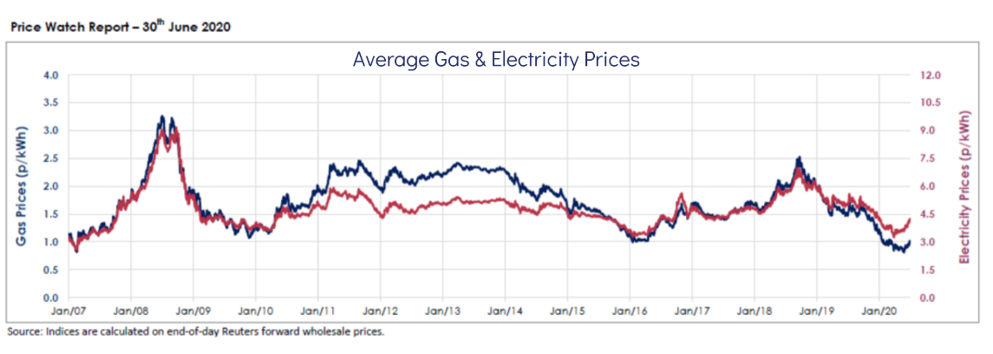
Here is what one customer had to say about their experience:

"We are a large GP surgery, in a multi-purpose building and so getting a good deal on our utilities is really important to us and our tenants. We have used several brokers over the years, often finding them rather pushy and confusing, but have recently opted for the Beond Group, who we found through the LMC Buying Group.
They have an excellent range of the market, present the information very clearly, and can talk you through the benefits of the different variables. And once agreed, the process is very smooth. I am an extremely happy customer and recommend the Beond Group to all GP Surgeries"
Rachel Stark, Practice Manager

This was a good purchasing decision for those who opted in as they have benefited from low energy prices. The LMC Buying Group have teamed up with Beond once again to open up the collective to you and provide an early opportunity to participate in the next Collective in October.
You will benefit from the most competitive energy prices, with a guarantee that your electricity will come from green sources at no additional premium. They will also take care of any energy supplier billing issues you face.

You can benefit from their energy collective today by completing this form and a consultant from Beond will be in touch to secure your place.
